Malthusian Population Checks and Policy Reflections:
Evidence from Preventive and Positive Mechanisms

By
Kanokphan Sirithienthong | 6610750092
Phurin Meechanchuang | 6610754250
Monprach Pattamakeansai | 6610750459
Athipat Suriam | 6610750629
Nathorn Apichaikriengkrai | 6610750190
Rapeerat Chen | 6610750483

Section 415
Submitted to:
Assoc.Prof. Kanokwan Chancharoenchai, Ph.D

History of Economic Thought
Bachelor of Economics (English Program)
Kasetsart University

First Semester, Academic Year 2025

Abstract
This report examines Malthus’s theory of population checks, emphasizing Positive and Preventive mechanisms (Chapter 6: Classical Economics after Smith). Using China’s One Child Campaign and Thailand’s ‘พร้อมก่อนมีลูก’ as case studies, it contextualizes Malthusian insights in modern demographic policy. The analysis highlights how state-led and voluntary birth control reflect enduring tensions between population growth and subsistence. All interpretations are grounded in course materials and classical critiques.
Section I: Introduction
The question of population growth and its implications for economic sustainability has long occupied the attention of economists and policymakers alike. Among the earliest and most influential voices in this discourse was Thomas Robert Malthus, whose Essay on the Principle of Population (1798) introduced a sobering view of demographic dynamics. Malthus argued that while population tends to grow in a geometric ratio, the means of subsistence—particularly food—can only increase arithmetically. This imbalance, he warned, would inevitably lead to a crisis unless checked by natural or societal mechanisms (Chapter 6: Theory of Population).
At the heart of Malthus’s framework lies the concept of population checks, which he classified into two categories: Positive Checks, which raise the death rate through famine, disease, and hardship; and Preventive Checks, which lower the birth rate via delayed marriage, moral restraint, and socio-economic considerations. These checks, he believed, were not only inevitable but essential to restoring equilibrium between population and resources.
In the contemporary policy landscape, echoes of Malthusian logic can be found in demographic interventions aimed at managing fertility and ensuring sustainable development. This report examines two such cases: China’s One Child Campaign, a state-enforced preventive measure, and Thailand’s ‘พร้อมก่อนมีลูก’ initiative, a voluntary campaign promoting readiness before childbirth. Both policies, though differing in approach and intensity, reflect the enduring relevance of Malthus’s insights into population control.
By grounding the analysis in classical economic thought, this report seeks to demonstrate how historical theories continue to inform modern policy design. The following sections will explore the theoretical underpinnings of Malthusian checks, assess their application in selected policy cases, and reflect on the broader implications for economic planning and social welfare.
Section II: Malthusian Framework of Population Checks
Thomas Malthus’s population theory, as presented in An Essay on the Principle of Population (1798), offers a foundational lens through which demographic pressure and resource scarcity can be understood. His framework is built on two postulates: that food is essential for human survival, and that the “passion between the sexes” remains constant. From these, Malthus deduced that population tends to grow faster than the means of subsistence, leading to inevitable tension between human numbers and available resources (Chapter 6: Theory of Population).
To address this imbalance, Malthus introduced the concept of checks to population, which operate either by increasing mortality (Positive Checks) or by reducing fertility (Preventive Checks). Positive Checks include famine, disease, and poor living conditions—factors that raise the death rate when subsistence falls short. Preventive Checks, on the other hand, involve behavioral and institutional mechanisms such as delayed marriage, moral restraint, and economic discouragement of large families. These checks serve to lower the birth rate before scarcity becomes critical.
Malthus emphasized that without effective Preventive Checks, societies would inevitably face the harsher consequences of Positive Checks. In his view, the subsistence wage—the minimum required for survival—acts as a natural boundary. When wages rise above this level, population growth accelerates, eventually outstripping food supply and triggering a reversal through starvation and illness. This cyclical dynamic underscores the fragility of unchecked population expansion.
Importantly, Malthus’s theory was not merely descriptive but prescriptive. He advocated for policies that would encourage moral restraint and economic prudence, viewing these as preferable to the suffering caused by Positive Checks. His skepticism toward the “perfectibility of society” stemmed from a pragmatic understanding of biological and economic limits.
In the context of modern policy, Malthusian checks remain relevant. The next section will examine how two contemporary campaigns—China’s One Child Policy and Thailand’s ‘พร้อมก่อนมีลูก’ initiative—reflect the logic of Preventive Checks, offering insight into how demographic control can be shaped by both coercive and voluntary mechanisms.

Section III: Case Study I — China’s One Child Campaign as a Preventive Check
China’s One Child Campaign, formally introduced in 1979 and enforced throughout the 1980s, stands as one of the most prominent examples of a state-imposed Preventive Check in modern history. While Malthus emphasized voluntary mechanisms such as delayed marriage and moral restraint to curb population growth, China’s policy extended this logic into the realm of legal enforcement—reflecting a more centralized and interventionist interpretation of Malthusian principles.
The campaign was designed to address the rapid population expansion that threatened to outpace the country’s agricultural and industrial capacity. In Malthusian terms, the policy aimed to prevent the geometric growth of population from colliding with the arithmetic growth of subsistence. By limiting families to a single child, the Chinese government sought to proactively reduce birth rates and avoid the harsher consequences of Positive Checks, such as famine, poverty, and disease.
The demographic impact of the policy is clearly illustrated in Figure 1, which shows the decline in China’s birth rate following the implementation of the One Child Policy. The graph highlights a sustained reduction in fertility from the early 1980s onward, while the death rate remained relatively stable. This trend reflects the effectiveness of the policy in suppressing population growth, aligning with Malthus’s preventive logic.
Figure 1: Decline in China’s birth rate following the implementation of the One Child Policy
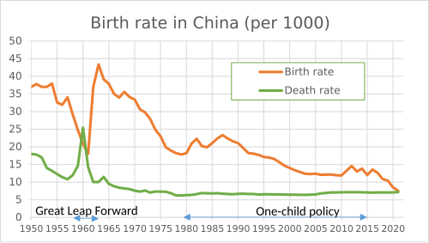
Source: Wikipedia
Although Malthus did not advocate coercive measures, his framework allows for the interpretation of such policies as extensions of Preventive Checks—particularly when moral restraint alone proves insufficient. The One Child Campaign operated through a combination of incentives, penalties, and administrative oversight. These included employment restrictions, access to public services, and most notably, financial penalties for non-compliance.
Figure 2 presents the variation in fertility fine rates across Chinese provinces between 1985 and 2000. The data reveal significant regional differences in enforcement intensity. For example, Beijing imposed fines equivalent to nearly six years of income at its peak, while Shanghai maintained relatively lower and more stable rates. This heterogeneity underscores the localized nature of policy implementation and its economic burden on households.
Figure 2: Fertility fine rates by province under the One Child Policy, 1985–2000
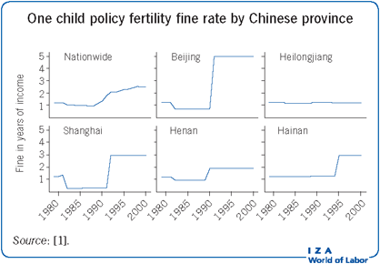
Source: IZA World of Labor
While the campaign succeeded in curbing population growth, its long-term consequences—such as gender imbalance, accelerated aging, and labor shortages—highlight the complexity of applying Malthusian logic in a modern socio-economic context. These outcomes reveal the tension between short-term subsistence management and long-term demographic sustainability.
In summary, China’s One Child Campaign exemplifies a state-led Preventive Check in the Malthusian tradition. It demonstrates how classical economic thought can inform policy design, while also exposing the limitations and unintended effects of strict fertility control.
Section IV: Case Study II — Thailand’s ‘พร้อมก่อนมีลูก’ Campaign as a Preventive Check
Thailand’s ‘พร้อมก่อนมีลูก’ campaign, translated as “Ready Before Having Children,” exemplifies a modern, voluntary approach to population management grounded in behavioral and socio-economic readiness. Unlike China’s state-enforced fertility control, this initiative operates through public education, cultural messaging, and institutional support—aligning with Malthus’s concept of Preventive Checks based on moral restraint and delayed reproduction.
The campaign encourages individuals and couples to consider emotional maturity, financial stability, and relationship preparedness before starting a family. These themes reflect Malthus’s original emphasis on delaying marriage and reducing fertility as a means to avoid subsistence pressure. Rather than imposing penalties, the Thai approach relies on informed choice and social norms to influence demographic behavior.
The long-term demographic impact of such voluntary restraint is evident in Figure 3, which presents Thailand’s declining fertility and population growth rates from 1960 to 2017. Panel (a) shows the Total Fertility Rate falling from over 6 children per woman in 1960 to below the replacement level of 2.1 by the early 1990s, and continuing to decline thereafter. Panel (b) illustrates a parallel drop in the Population Growth Rate, from over 3% to below 0.5% over the same period. These trends suggest that Thailand’s population dynamics have stabilized significantly, consistent with the goals of preventive demographic management.

Figure 3: Total fertility rate and population growth rate in Thailand. Dashed line is replacement fertility, 2.1 children/woman.
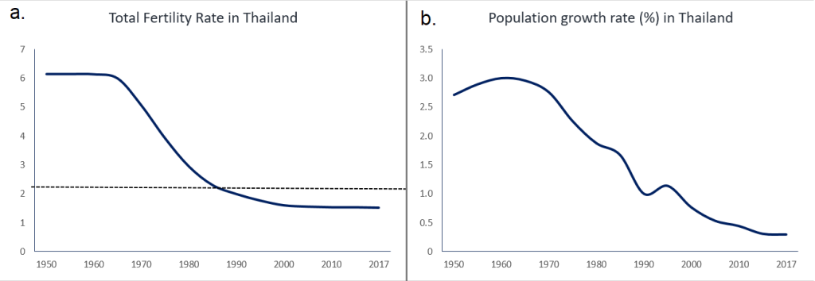
Source: Overpopulation Project
Complementing these trends is the rise in contraceptive use, which reflects the behavioral foundation of Thailand’s fertility moderation strategy. As shown in Figure 4, the percentage of married women aged 15–44 using contraception rose steadily from approximately 40% in 1969 to over 70% by the mid-1990s. This increase indicates widespread adoption of family planning practices, driven not by coercion but by public health campaigns and social acceptance.
Figure 4: Prevalence of Contraceptive Use Among Married Women Aged 15–44 in Thailand, 1969–1996
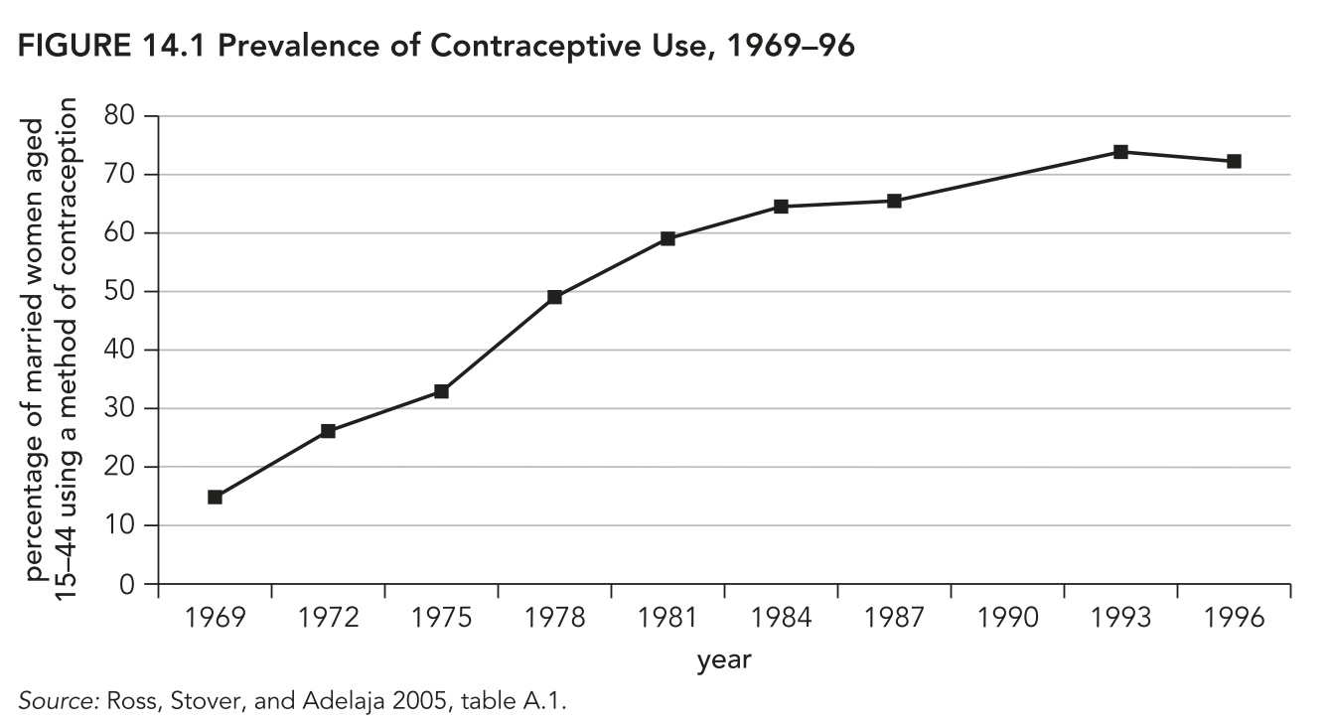
Source: Ross, Stover, and Adelaja 2005, table A. 1.
While the ‘พร้อมก่อนมีลูก’ campaign does not claim sole credit for these shifts, it represents a continuation of Thailand’s broader commitment to voluntary fertility moderation. The campaign’s success depends on cultural receptivity, economic opportunity, and the strength of public institutions—factors that Malthus acknowledged as critical to the effectiveness of Preventive Checks.
In summary, Thailand’s ‘พร้อมก่อนมีลูก’ initiative reflects a non-coercive Preventive Check, emphasizing readiness and informed decision-making. It demonstrates how Malthusian principles can be adapted to contemporary contexts through voluntary mechanisms, offering a contrast to state-enforced models and highlighting the role of individual agency in demographic policy.
Section V: Comparative Reflection — Coercion and Voluntarism in Preventive Population Checks
The comparative analysis of China’s One Child Campaign and Thailand’s ‘พร้อมก่อนมีลูก’ initiative reveals two distinct interpretations of Preventive Checks within the Malthusian framework. Both policies aim to reduce fertility rates before subsistence constraints become critical, yet they diverge sharply in their mechanisms, social reception, and long-term implications.
China’s approach reflects a coercive model, where fertility control is enforced through legal mandates, financial penalties, and administrative oversight. As illustrated in Figure 1 and Figure 2, the policy achieved rapid demographic impact, with birth rates declining sharply and provincial fine rates reinforcing compliance. However, the campaign’s rigidity produced unintended consequences—gender imbalance, accelerated aging, and labor shortages—that challenge its long-term sustainability.
In contrast, Thailand’s strategy embodies a voluntary model, grounded in behavioral change and public education. The ‘พร้อมก่อนมีลูก’ campaign promotes readiness before childbirth, aligning with Malthus’s emphasis on moral restraint. As shown in Figure 3, fertility and population growth rates declined steadily over decades, while Figure 4 highlights the rise in contraceptive use as a key behavioral driver. This gradual shift reflects the power of social norms and institutional support in shaping demographic outcomes without coercion.
From a policy perspective, both models demonstrate the relevance of Malthusian checks in modern contexts. China’s campaign illustrates the efficiency—but also the risks—of centralized enforcement. Thailand’s initiative shows how preventive logic can be adapted to democratic and culturally sensitive environments, where individual agency plays a central role.
Ultimately, the contrast between coercion and voluntarism underscores a broader lesson: while Malthus’s theory remains foundational, its application must be context-sensitive, ethically grounded, and responsive to long-term socio-economic dynamics. The balance between demographic control and human dignity remains a central challenge for policymakers navigating population pressures in the 21st century.

Conclusion
This report has revisited Malthus’s theory of population checks through the lens of two contemporary policy cases: China’s One Child Campaign and Thailand’s ‘พร้อมก่อนมีลูก’ initiative. Both policies reflect the logic of Preventive Checks, aiming to reduce fertility before subsistence constraints become critical. Yet their contrasting approaches—coercive versus voluntary—highlight the diverse ways in which Malthusian principles can be interpreted and applied.
China’s campaign demonstrates the efficiency of centralized enforcement, achieving rapid demographic shifts but also exposing long-term socio-economic vulnerabilities. Thailand’s initiative, by contrast, illustrates the power of behavioral change and public education in shaping fertility preferences over time. The integration of visual data—fertility trends, population growth rates, and contraceptive prevalence—reinforces the analytical depth of both cases and their alignment with classical economic thought.
Ultimately, the enduring relevance of Malthus’s framework lies not in its rigidity but in its adaptability. As societies continue to navigate the balance between population dynamics and resource sustainability, the lessons of preventive restraint, institutional design, and ethical policy remain central. Whether through state mandates or cultural campaigns, the challenge remains the same: to manage demographic pressures with foresight, equity, and respect for human agency.
Reference
Malthus, T. R. (1798). An Essay on the Principle of Population. Reprinted in Chapter 6: Theory of Population, Classical Economics after Smith, course materials.
Ross, J., Stover, J., & Adelaja, D. (2005). Contraceptive Use, Fertility, and Population Growth in Developing Countries. Table A.1. Retrieved from https://www.popline.org/node/263563
Wang, F. (2019). How does the one-child policy impact social and economic outcomes? IZA World of Labor. Retrieved from https://wol.iza.org/articles/how-does-the-one-child-policy-impact-social-and-economic-outcomes/long
Wikipedia contributors. (2025, October 30). One-child policy. Wikipedia. Retrieved from https://en.wikipedia.org/wiki/One-child_policy
National Statistical Office of Thailand. (n.d.). Demographic Trends in Thailand, 1960–2017. Visual data retrieved from official Thai demographic reports and public health archives.

